Choose a company that publicly traded (stock)

MSFT
-yahoo finance (https://finance.yahoo.com/)
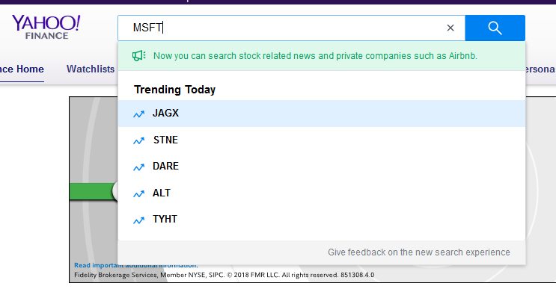

What is the stock symbol?

Pull daily stock closing prices for the last 6 months. (change time period and frequency)

-Click on Historical Data
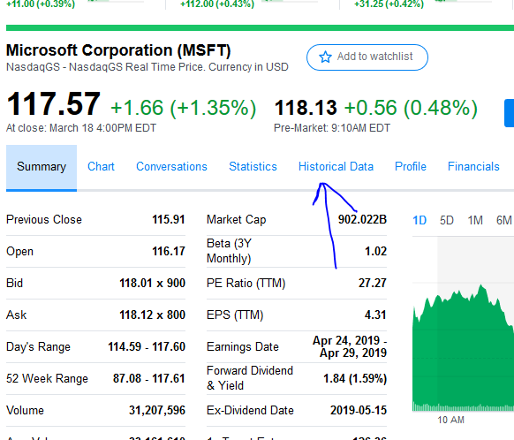
-Change the time period to 6mo and frequency to daily
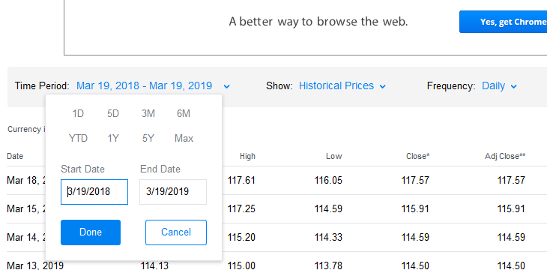

Download the data in excel.
-click download data
-save the close prices
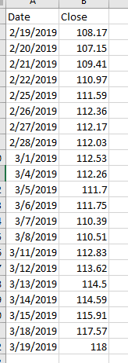

Create a chart (scatterplot) looking at the data
-insert
-recommended charts
-scatterplot

Determine the how much you could have made if you purchased 1,000 shares of stock at the lowest price then sold those shares at the highest price in that time period.
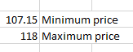

107.15*1000 = $107,500
118*1000 = $118,000

I would have made $118,000 - $107,500 = $10,500

