Title:
Relationship between entrepreneurial marketing and firm performance of Apollo Food Holdings Berhad

Key words:
Variables (Independent variable = IV; Dependent variable = DV; Moderator = MV) | References | Adopted key terms/ questionnaire | Theory for the variable | References | Adopted key terms
IV1: market driving | Egger, et al., 2018 | We always try to develop new products that should challenge our customers to rethink their purchasing behaviors.  We are market pioneers and act on the assumption that consumers and competitors follow us.  We consistently pick up ideas from other industries to surprise our customers and competitors.  We consistently develop new, spectacular marketing concepts, which our competitors imitate.
IV2: resource leveraging | Egger, et al., 2018 | In our business, we use connections to friends, business partners, etc. to get cost-efficient access to information and advice.  In our business, we explore options to operate in cost-efficient ways.  In our business, we use equipment, machinery, and facilities as long as they serve their purpose, although we could afford more modern replacements.  In our business, we purchase equipment and machinery since leasing on a case-by-case basis is not an option.  In our business, we lease our personnel, equipment, and rooms if they are not used to capacity over a longer period of time.  We work with other firms to refer business in order to save on marketing costs.  We use connections to other firms to increase our offerings in cost-efficient ways.  Our employees do not expect immediate rewards whenever they increase their commitment.
IV3:  consumer orientation | Egger, et al., 2018 | We constantly monitor our level of commitment and orientation to serving customer needs.  We freely communicate information about our successful and unsuccessful customer experiences across all business functions.  Our strategy for competitive advantage is based on our understanding of customer needs.  We measure customer satisfaction systematically and frequently.  We are more customer-focused than our competitors.  I believe this business exists primarily to serve customers.  Data on customer satisfaction is disseminated at all levels in this business unit on a regular basis.
IV4: risk taking | Egger, et al., 2018 | We value new strategies/plans even if we are not certain they will always work.  To make effective changes to our offering, we are willing to accept at least a moderate level of risk of significant losses.  We encourage people in our company to take risks with new ideas.  We engage in risky investments (e.g. new employees, facilities, debt, stock options) to stimulate future growth.
DV: firm performance of Apollo Food Holdings Berhad | Egger, et al., 2018 | In the last five years, we achieved a higher revenue growth than our (direct/indirect) competitors.  In the last five years, we achieved a higher profit growth than our (direct/indirect) competitors.  In the last five years we achieved a higher growth in employees than our (direct/indirect) competitors.  In the last five years we achieved a higher market share growth than our (direct/indirect) competitors. | Resource-based theory  Organizational learning theory  Effectuation theory | Omar, et al., 2016  Smriti and Das, 2018  Kujala and Tornroos, 2018 | Resource-based theory explains how a firm’s resources (i.e., assets, capabilities, organizational process, firm attributes, information and knowledge) act as sources of competitive advantage for an organization (Barney 1991). Resources that are valuable, rare, inimitable and without substitutes allow firms to develop and implement strategies to improve their competitive advantage.  Based on resource-based view (RBV) theory, knowledge is a valuable resource because it has unique characteristics and is difficult to imitate.  Based on organizational learning theory, firms can acquire long-term wealth and sustainability by following continuous learning. Organizational learning theory recognizes the process of continuous learning inside the organization and brings innovation in product and process. As per the organizational learning theory, the firm can build long-term sustainability by continuous upgrading of knowledge, which, in turn, contributes to innovation which helps in meeting the market demand.  The effectuation approach is a perspective from which an understanding can be gained of how SME-entrepreneurs make decisions and behave in their search for new market opportunities.  effectuation rather than causation,4 provides a better understanding of entrepreneurs and SMEs decision-making during internationalization. Five main principles of effectuation are presented in the literature:  1. employing the existing means  2. putting focus on the affordable losses  3. leveraging contingencies  4. focusing on relationships  5. controlling rather than predicting

Research problem/ research gap:
The problems of firm performance of Apollo Food Holdings Berhad can be caused by problems of market driving, resource leveraging, consumer orientation, risk taking, however no past research literatures reviewed causes to these problems in non-SMEs in Malaysia like Apollo Food Holdings Berhad, hence researcher is to fill knowledge in this research gap by researching on relationship between entrepreneurial marketing and firm performance of Apollo Food Holdings Berhad.

Framework:
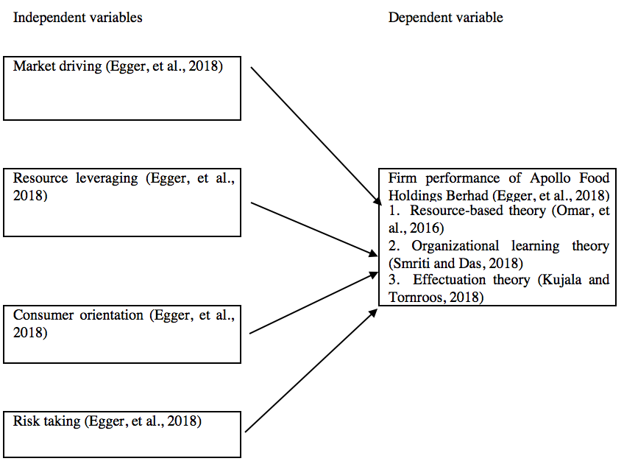

Research methodology:
quantitative method, positivism methodology, deductive approach, descriptive explanatory research, questionnaire technique, non-probability convenient sampling method, 200 respondents who are employees working in Apollo Food Holdings Berhad to research on the relationship between entrepreneurial marketing and firm performance of Apollo Food Holdings Berhad

Hypotheses:
H1: There is a significant relationship between market driving and firm performance of Apollo Food Holdings Berhad
H2: There is a significant relationship between resource leveraging and firm performance of Apollo Food Holdings Berhad
H3: There is a significant relationship between consumer orientation and firm performance of Apollo Food Holdings Berhad
H4: There is a significant relationship between risk taking and firm performance of Apollo Food Holdings Berhad

References:
IV1 IV2 IV3 IV4 DV:
Eggers, F., Niemand, T., Kraus, S., & Breier, M. (2018). Developing a scale for entrepreneurial marketing: Revealing its inner frame and prediction of performance. Journal of Business Research.

Apollo annual report 2018:
Apollo Food Holdings Berhad. (2018). Annual Report 2018. [online]. Available at: <disclosure.bursamalaysia.com/FileAccess/apbursaweb/download?id=188928&name=EA_DS_ATTACHMENTS>[accesed on 7th February 2019]

Resource-based theory:
Omar, N. A., Aris, H. M., & Nazri, M. A. (2016). The Effect of Entrepreneurial Orientation, Innovation Capability and Knowledge Creation on Firm Performance: A Perspective on Small Scale Entrepreneurs. Jurnal Pengurusan, 48, 1–23

Organizational learning theory:
Smriti, N., & Das, N. (2018). The impact of intellectual capital on firm performance: a study of Indian firms listed in COSPI. Journal of Intellectual Capital, 19(5), 935.

Effectuation theory:
Kujala, I. and Tornroos, J. A. (2018). Internationalizing through networks from emerging to developed markets with a case study from Ghana to the U.S.A. Industrial Marketing Management. 69, 98-109.

1.
Majovski, I., & Davitkovska, E. (2017). Entreprenurial Marketing Management: The New Paradigm. Economic Development / Ekonomiski Razvoj, 19(1/2), 147–165.
2.
Ibrahim, M. A., & Shariff, M. N. M. (2016). Mediating Role Of Access To Finance On The Relationship Between Strategic Orientation Attributes And Smes Performance In Nigeria. International Journal of Business & Society, 17(3), 473–496.
3.
Omar, N. A., Aris, H. M., & Nazri, M. A. (2016). The Effect of Entrepreneurial Orientation, Innovation Capability and Knowledge Creation on Firm Performance: A Perspective on Small Scale Entrepreneurs. Jurnal Pengurusan, 48, 1–23
4.
Mamun, A. A., Mohiuddin, M., Fazal, S. A., & Ahmad, G. B. (2018). Effect of entrepreneurial and market orientation on consumer engagement and performance of manufacturing SMEs. Management Research Review, 41(1), 133.
5.
Pratono, A. H., & Mahmood, R. (2015). Entrepreneurial orientation and firm performance: How can micro, small and medium-sized enterprises survive environmental turbulence? Pacific Science Review B: Humanities and Social Sciences, 1, 85–91.
6.
Lekmat, L., Selvarajah, C., & Hewege, C. (2018). Relationship between Market Orientation, Entrepreneurial Orientation, and Firm Performance in Thai SMEs: The Mediating Role of Marketing Capabilities. European Journal of Pediatric Dermatology, 28(4), 213–237.
7.
Dikova, D., Jaklič, A., Burger, A., & Kunčič, A. (2016). What is beneficial for first-time SME-exporters from a transition economy: A diversified or a focused export-strategy? Journal of World Business, 51, 185–199.
8.
Montiel-Campos, H. (2018). Entrepreneurial orientation and market orientation. Journal of Research in Marketing & Entrepreneurship, 20(2), 292.
9.
Smriti, N., & Das, N. (2018). The impact of intellectual capital on firm performance: a study of Indian firms listed in COSPI. Journal of Intellectual Capital, 19(5), 935.
10.
Palacios, M. D., Devece, C. C., & Llopis, A. C. (2016). Examining the Effects of Online Social Networks and Organizational Learning Capability on Innovation Performance in the Hotel Industry. Psychology & Marketing, 33(12), 1126–1133.
11.
Da, P. B. C. M. De, O. C. J. E., Fernandes, C. F. J. and Fernandes, M. C. A. (2015). Capabilities, Innovation, and Overall Performance in Brazilian Export Firms. Revista de Administração Mackenzie, 16(3), 76–108.
12.
Kujala, I. and Tornroos, J. A. (2018). Internationalizing through networks from emerging to developed markets with a case study from Ghana to the U.S.A. Industrial Marketing Management. 69, 98-109.
13.
Sulistyo, H. and S. (2016). Innovation capability of SMEs through entrepreneurship, marketing capability, relational capital and empowerment. Asia Pacific Management Review. 21, 196-203.
14.
Sahid, S. and Habidin, N. F. (2018). Exploring Measurement Model for Entrepreneurial Marketing Construct: A Marketing for SME’s. International Journal of Supply Chain Management. 7(6), 674-683
15.
Peterson, M. (2018). Modeling country entrepreneurial activity to inform entrepreneurial-marketing research. Journal of Business Research.
16.
Kilicer, T. (2016). Kobi̇’Leri̇n Gi̇ri̇şi̇mci̇ Pazarlama Profi̇lleri̇ Üzeri̇ne Bi̇r Araştirma. Suleyman Demirel University Journal of Faculty of Economics & Administrative Sciences, 21(3), 819–843.
17.
H, A. R., K, A. W., & A, S. (2015). The Shift from Traditional Marketing to Entrepreneurial Marketing Practices: A Literature Review.
18.
Abu, S. M. M. H. and Zainudin, B. A. (2019). Does gender difference play moderating role in the relationship between entrepreneurial marketing and Bangladeshi SME performance? Accounting, Vol 5, Iss 1, Pp 35-52 (2019), (1), 35.
19.
Alqahtani, N., & Uslay, C. (2018). Entrepreneurial marketing and firm performance: Synthesis and conceptual development. Journal of Business Research.
20.
Peterson, R. A., & Crittenden, V. L. (2018). Exploring customer orientation as a marketing strategy of Mexican-American entrepreneurs. Journal of Business Research.
21.
Hernández, P. F., Moreno, G. J., & Yáñez, A. B. (2017). Family firm performance: The influence of entrepreneurial orientation and absorptive capacity. Psychology & Marketing, 34(11), 1057–1068.
22.
Chang, Y., Wang, X., & Arnett, D. B. (2018). Enhancing firm performance: The role of brand orientation in business-to-business marketing. Industrial Marketing Management.
23.
Cacciolatti, L., & Lee, S. H. (2016). Revisiting the relationship between marketing capabilities and firm performance: The moderating role of market orientation, marketing strategy and organisational power. Journal of Business Research, 69, 5597–5610.
24.
Zhang, J. A., Edgar, F., Geare, A., & O’Kane, C. (2016). The interactive effects of entrepreneurial orientation and capability-based HRM on firm performance: The mediating role of innovation ambidexterity. Industrial Marketing Management, 59, 131–143.
25.
Au, E. W. M., Qin, X., & Zhang, Z.-X. (2017). Beyond personal control: When and how executives’ beliefs in negotiable fate foster entrepreneurial orientation and firm performance. Organizational Behavior and Human Decision Processes.
26.
Kraus, S., Kallmuenzer, A., Stieger, D., Peters, M., & Calabrò, A. (2018). Entrepreneurial paths to family firm performance. Journal of Business Research, 88, 382–387.
27.
Sanna Joensuu-Salo, Kirsti Sorama, Anmari Viljamaa, & Elina Varamäki. (2018). Firm Performance among Internationalized SMEs: The Interplay of Market Orientation, Marketing Capability and Digitalization.
28.
Jiang, X., Yang, Y., Pei, Y.-L., & Wang, G. (2016). Entrepreneurial Orientation, Strategic Alliances, and Firm Performance: Inside the Black Box. Long Range Planning, 49, 103–116.
29.
Crick, J. M., Crick, D., & Chaudhry, S. (2018). Entrepreneurial marketing decision-making in rapidly internationalising and de-internationalising start-up firms. Journal of Business Research.
30.
Jiang, X., Liu, H., Fey, C., & Jiang, F. (2018). Entrepreneurial orientation, network resource acquisition, and firm performance: A network approach. Journal of Business Research, 87, 46–57.

