University of Sunderland

Faculty of Computer Science

CETM23 – Big Data in Organisations

Assignment 1 of 1 – 100% of the summative value of the module

Extract from module descriptor – The module will be assessed by one coursework assignment (5000 words) which will cover all learning outcomes of the module. Students will undertake research and have the opportunity to create a strategic overview and action plan outlining the benefits, opportunities and challenges associated with big data in the context of the given organisational problem scenario.

Assignment

The following learning outcomes will be assessed:

- Critical appreciation of the principles and practical applications of Big Data and Big Data sets in the business / organisational context.

- Critical analysis of the strategic challenges and opportunities afforded by Big Data to organisations and / or to specific subject domains

- The ability to undertake research into the strategic and operational use of Big Data in organisations taking into account the nature of Big Data, the validity of Big Data, authentication, anonymity, visualisation

- Analysis and evaluation of the professional and ethical requirements of Big Data in organisational or subject specialist domain

Students should reflect the detail in the learning outcomes in the deliverables for the assignment.

Important Information

You are required to submit your work within the bounds of the University Infringement of Assessment Regulations (see your Programme Guide).

For this assessment you are asked to submit an individual piece of work, therefore the work must be entirely your own.

Referencing for this assessment should be done using the Harvard referencing system. (see your Programme Guide).

Submission Date and Time | Report by Friday, 12 April, 2019 by 23.59 GMT
Submission Location | Digital copy via Canvas

Feedback due wb 6th May 2019

Assignment Specification

The assignment is based on the data requirements for the organisation – Mouse Catchers Incorporated (MCI). MCI operate in a geographic area covering 40,000 km². The company has a Managing Director, a Director of Operations, a Finance Director, 2 Team Managers, 12 Vermin Control Operatives, one Technical Guru and one IT specialist. Currently MCI operates a service for eradicating mice and other vermin from private and commercial premises. In order to control mice infestations MCI deploy 50,000 mouse and rat traps on commercial sites and 20,000 on private buildings. MCI has 3000 commercial customers with an average of 15 traps on each site and 10,000 private customers with an average of 2 traps per dwelling.

The 2 team managers arrange a schedule for the Vermin Control Operatives to routinely check the 50,000 traps for commercial sites. This takes 4 weeks to go through a cycle of checking all the traps. Commercial customers can call MCI and ask for an operative to come on site if they think that one of the traps has been activated. Operatives only go to private residences if they are called out by the private customer.

The operation is currently inefficient and expensive. Private customers are charged $60 a year and $25 for a call out. Commercial organisations are charged $1000 a year and $200 for a call out.

MCI want to improve their operation and have decided to invest in Internet of Things (IofT) traps made by a company called “Xignal”, see figure 1 below. These traps are battery operated and send a signal to MCI once a week when they are empty (i.e. no vermin has been caught). Batteries have an expected life of 10 years, but can fail at any time. When a mouse or rat has been caught a positive signal is sent from the trap back to MCI.

It is anticipated that the data from the new devices and the planned big data system will improve efficiency of MCI’s operation by replacing the planned visit schedule with visits only happening when a positive signal is sent from the IofT trap, or when a customer requests a check.

Customer details are in the form of structured data but the signals, battery life and call out data are unstructured.

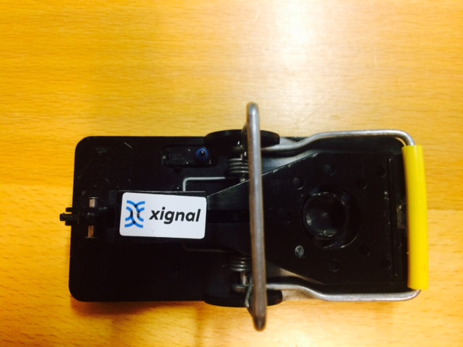

Figure 1 – Internet of Things Trap

Deliverables

The purpose of this assessment is to create a data strategy report and commentary

Data Strategy Report (100 marks)

Your report should provide a commentary on the proposed Data Strategy for Mouse Catchers Incorporated.

Your commentary should cover the following sections

Overview of the problem (20 marks 1250 words) – your understanding of the current issues, the data currently available, the opportunities for the proposed system, the data analysis requirements for the proposed system and what MCI could do with the data to maximise the opportunities for their operation. Marks awarded for understanding of the problem domain and the role data plays in the organisational challenges.

Questions to ask the organisation (including a range of different types of question) (10 marks 750 words) – this should be informed from the perspective of data analysis and should consider strategic data requirements (trap data, redundant data, inaccurate data, missing data, other data). You should also include your understanding of the data available, issues with data sets and what additional data is required. Marks awarded for the interpretation of the data opportunities and the data questions that arise from consideration of the data available and the data requirements for the organisation in the use of the IofT devices.

Data Analytics (20 marks 1500 words) – this section of the report should discuss the strengths, weaknesses and gaps in the data and the interpretation of the data. Possible topics to consider include (but are not restricted to) what could the IofT data tell the organisation, what patterns should be observed, where are potential weaknesses in the data and in the system, what does the data tell the organisation about opportunities for future expansion. Marks awarded for consideration of the use of data analytics to the organisational requirements of MCI.

Strategic Action Plan (20 marks 500 words) – recommendations from your findings about what the MCI should do from a data perspective to implement the IofT solutions, including any considerations of Non Disclosure Agreements. Marks awarded for completeness of action plan, showing strategic thinking, identifying strategic and operational opportunity and maximising the use of data, data analytics and data science from an organisational perspective.

Professional Reflection (20 marks 750 words) – you should use this part of your commentary to consider ethical issues with the exercise and your professional development in the assignment (what have you learned, what skills have you developed, what you might do differently the next time you tackle this type of problem). Marks awarded for critical personal reflection and consideration of assignment on student’s data science practice.

Conclusion (10 marks 250 words) – summary of the main findings of your report. Marks awarded for succinctness and completeness of conclusion.

References (10 marks, no word limit)– to be in Harvard Style referencing
Marks awarded for relevance of references, currency of references and breadth of references.

