Population Ecology exercises.

All these exercises together are worth 55 points total.

Name: Mohamad Issa

Student #: B00064481

**Part 1 Examples of mark-recapture studies.**

Dr. Bartholomew will present a short lecture on mark-recapture studies. After that talk, you should search online for an actual mark-recapture study, and answer these questions:

What type animal was marked / recaptured (1)

How did the researchers “mark” the animal? (1)

What was / were the overall purpose(s) of the study? Were the researchers estimating population size? Studying migration? Estimating animal growth rates? Other reasons? (2)

Cite your source, below (you will not get any of the above points until you cite a source, an internet link is acceptable):

(http://xcelab.net/rm/wp-content/uploads/2009/04/mark-recapture-intro.pdf.)

I suggest you go to google scholar to search for studies. Many of the papers here are “review” papers or “methods” papers that do not show the result of a single, particular study that deals with one species in a mark-recapture study. You need a paper about results from a particular study, so do not use these review / methods papers. You must pick a paper different than the results presented by Dr. Aaron already, obviously.

**Part 2 Surveying African elephants**

Here’s the elephant survey methods link:

<https://www.biointeractive.org/classroom-resources/survey-methods>

Start with “launch interactive”.

Read through the slides (by paging sideways) and be sure to watch all of each video on slides that have an imbedded video. As you are reading this material and watching the videos, answer the questions below. It is probably a good idea to read the questions first, before you proceed, so you know what to look for when you are doing the reading / video watching.

Questions below are modified from: https://www.biointeractive.org/sites/default/files/media/file/2021-01/SurveyMethods-StudentWS-CL.pdf

**INTRODUCTION**

The story of African elephants is a powerful example of how science can inform conservation. Knowing how many elephants are left and where they live can help us plan strategies to protect them. In this exercise you’ll learn more about elephants and the methods used to monitor their populations. These methods can also be used to study many other large animals.

**Why Study Elephants?**

1. Elephants are considered to be a keystone species. What does that mean? (1)
2. Describe two savannah elephant activities or functions that justify labelling savannah elephants as a keystone species. Describe one forest elephant activity or function that justifies labelling forest elephants as a keystone species. (3)

3. What are two important reasons that elephant populations have been declining for the past several decades? (2)

**Survey Methods**

Biologists weigh the advantages and disadvantages of different survey methods before choosing the appropriate approach. Read through the survey methods under the **“Where Are They?”.** These methods were used to determine the range of the elephants: where they are present and absent in Africa.

Then read through the survey methods under the **“How Many?”** tabs. These methods were used to estimate elephant population size / densities in different parts of their range.

As you are going through this information, fill in the following table in your own words, do not just copy and paste information. The completed table is worth 28 points.

|  |  |  |  |  |  |
| --- | --- | --- | --- | --- | --- |
| **Survey type** | **Information gathered** | **Methods used** | **Type of count**  (total/sample, direct/indirect) | **Advantages** | **Disadvantages / Problems** |
| **Species range** |  |  | **N/A** | 1 advantage | 3 problems |
| **Individual range** |  |  | **N/A** | 3 advantages | 2 problems |
| **Aerial survey** |  |  |  | 2 advantages | 3 problems |
| **Individual registration** |  |  |  | 2 advantages | 2 disadvantages |
| **Acoustic survey** |  |  |  | 3 advantages | 2 disadvantages |
| **Dung transect** |  |  |  | 2 advantages | 2 disadvantages |

**Population Changes in Elephants**

Read through the **“Population Change”** tab, watch the video, and explore the map.

1. Turn on the 1979 and 2007 range layers on the map. Describe the change in the range. Where did the elephant range decrease dramatically? Where did it increase (look carefully, there are a few spots)? (2)
2. Turn off the 1979 and 2007 range layers, then turn on the 2016 trends layer.
   1. Based on the area surveyed, where are the major hotspots of elephant decline? (1)

b. Where are elephant populations stable or increasing? (1)

**Part 3 Population growth models**

Go to the following website: <https://www.biointeractive.org/classroom-resources/population-dynamics>

Click “launch interactive”. Next click on “Exponential Growth Model”. Read the introductory material on “Exponential Growth Model”, then click on “Go to the simulator…”

Remember from chapter 11, that if population size is small (and thus there are plenty of resources available to each individual in the population) the population can experience exponential growth for a limited time, like this:

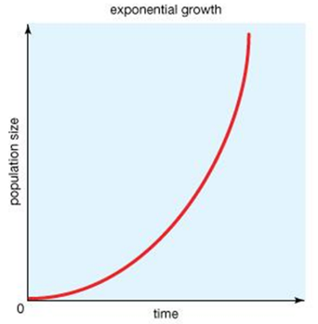

Use the initial parameters:

N0 = 100

r = 0.6

and click the “play” button beneath the graph. Note the shape of the curve, I will refer to this as the “initial curve”. The dashed green line is dN/dT, the population growth rate (the slope of the curve).

Next, change the parameters to:

N0 = 100

r = 1

and click the “play” button beneath the graph. Note the shape of the curve. The dashed green line is dN/dT, the population growth rate (the slope of the curve).

How does this curve (when we increase r, the per capita rate of increase) compare with the initial curve? (1) You may have to switch back and forth between 0.6 and 1 several times to see the difference.

Next, change the parameters to:

N0 = 100

r = 0.1

and click the “play” button beneath the graph. Note the shape of the curve. The dashed green line is dN/dT, the population growth rate (the slope of the curve).

How does this curve (when we decrease r, the per capita rate of increase) compare with the initial curve? (1) You may have to switch back and forth between 0.6 and 0.1 several times to see the difference.

Next, change the parameters to:

N0 = 10

r = 0.6

and click the “play” button beneath the graph. Note the shape of the curve. The dashed green line is dN/dT, the population growth rate (the slope of the curve). How does this curve (with lower initial population N0) compare with the initial curve? (1) You may have to switch back and forth between 100 and 10 several times to see the difference.

Next, click on “Logistic growth model” in the upper right, and read about the “logistic growth model”. Then, click on “Go to the simulator…”

Remember from chapter 11 that populations cannot have exponential growth for very long. Eventually a limiting factor (like food availability, or space for organisms attached to rocks in the ocean) limits population size, and the population reaches K, the carrying capacity of the environment for that species. This creates logistic population growth, as seen below:

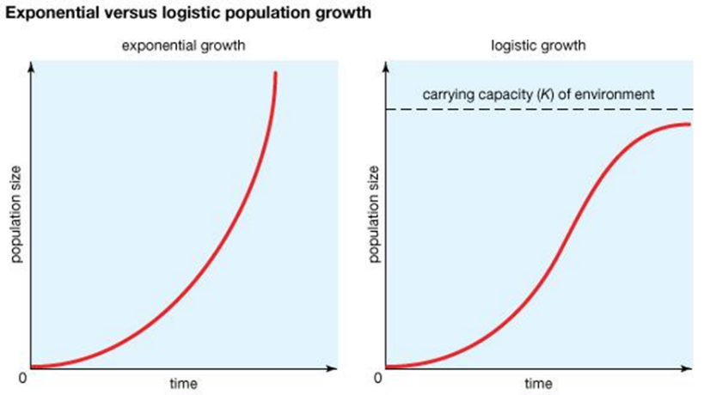

Set the parameters initially as:

Initial parameters:

N0 = 50

r = 0.6

k = 1500

In the lower right corner, for “time” change “max” to 20. Keep this box at 20 throughout this exercise.

Then click on the play button using the initial parameters. Note shape of this “initial curve”, which I will refer to later. The dashed green line is dN/dT, the population growth rate (the slope of the curve).

Next, change the parameters to:

N0 = 150

r = 0.6

k = 1500

and click the “play” button beneath the graph. Note the shape of the curve. The dashed green line is dN/dT, the population growth rate (the slope of the curve). How does this curve (with higher initial population N0) compare with the initial curve? (1) You may have to switch back and forth between 50 and 150 several times to see the difference.

Next, change the parameters to:

N0 = 50

r = 0.4

k = 1500

and click the “play” button beneath the graph. Note the shape of the curve. The dashed green line is dN/dT, the population growth rate (the slope of the curve). How does this curve (with lower per capita growth rate) compare with the initial curve? (1) You may have to switch back and forth between 0.6 and 0.4 several times to see the difference.

Next, change the parameters to:

N0 = 50

r = 0.6

k = 1000

and click the “play” button beneath the graph. Note the shape of the curve. The dashed green line is dN/dT, the population growth rate (the slope of the curve). How does this curve (with lower carrying capacity) compare with the initial curve? (1) You may have to switch back and forth between 1500 and 1000 several times to see the difference.

**Part 4 Wildebeests as an example of population growth and limiting factors**

Read the following information, and answer the questions.

Information from: https://www.biointeractive.org/classroom-resources/serengeti-wildebeest-population-regulation



Caption: Number of wildebeest in the Serengeti ecosystem (shaded circles, left y-axis) and the prevalence (i.e., percentage) of individuals infected by rinderpest disease (unshaded squares and triangles, right y-axis) from 1958 to 2003.

BACKGROUND INFORMATION

In the 1960s, wildlife managers in Serengeti National Park, Tanzania, noticed that the wildebeest population was increasing rapidly. Researchers began studying the cause of the sudden increase. To do this, they first had to understand what was controlling wildebeest numbers before the increase, and what changed in the 1960s. One candidate they considered was disease. Rinderpest is a viral disease that infects cattle, wildebeest, and other hoofed animals. The disease had affected cattle and wildlife in the Serengeti region for decades. Death rates were extremely high, especially among wildebeest calves. A program to vaccinate cattle began in the 1950s, and scientists monitored how the program affected wildebeest populations. In 2011, the United Nations declared that vaccination efforts had eradicated rinderpest across the globe. Rinderpest became the second viral disease, after smallpox, to be wiped out.

The researchers later went on to explore how the eradication of rinderpest, and the rise in wildebeest numbers, affected other species in the ecosystem. They found that with larger wildebeest populations there was more grass consumption. Researchers also observed a decrease in the amount of fires with more wildebeest, and an increase in the density of trees.

INTERPRETING THE GRAPH

The graph shows a rapidly declining percentage of wildebeest infected with rinderpest from 1958 to 1963, which coincides with the beginning of a vaccination program in 1960. This suggests that vaccines administered to cattle reduced rinderpest transmission from cattle to wildebeest. Eradication of the virus allowed the wildebeest population to rebound from around 200,000 animals in 1958 to around 1,200,000 in the late 1970s. Following this steep increase, the population stabilized. This suggests that the wildebeest population was controlled by disease before 1960 and was later controlled by a factor other than rinderpest disease.

Before 1960, disease limited the wildebeest population. Is this a density-dependent or density-independent factor? Explain your reasoning. (2)

Based on the trends in the graph, what do you think the approximate carrying capacity for the wildebeest population is? (pay close attention to the label on the y axis) (1)

What are some possible factors that could be controlling the wildebeest population after 1980? Are these density-dependent or density-independent factors? Explain your reasoning. (2)

How could an increase in wildebeest population lead to a reduction in fires? (1)

How could and increase in wildebeest population lead to an increase in tree density? (1)