Geneva Business School

Master of Business Administration

MOS 100
Marketing of Services

Study Materials

Video Cases
Panera Bread
Question 1

How would you see the SWOT for Panera? What happened to their original stores?

Question 2

What mixture of restaurant operations do they try to achieve.
How did they achieve the highest brand loyalty among food operations in the USA?
What does it mean to empower employees.?

Coca Cola- Hello Happiness
Question 1

What innovative idea made Coca Cola unique in this advertisement?

Question 2

When you ask Coca Cola what industry you are in?
They will say:………………………………………………….., (the answer is not carbonated soft drink industry!)

Marketing departments of Yoplait as well as Martha Stewart asked assistance from communication agencies for innovative branding.
Both asked the agency Questus The agency says about themselves:
“We’re digital natives. We started back when the web was still fresh, still uncharted territory. We used the skills we had at hand: Logic. Curiosity. Empathy. Imagination.

Our aim is to bring authenticity and transparency to the party. No longer just moving products off shelves but moving people to action. Not persuading them but empowering them to be the best they can by building experiences that hit home and ring true. Please watch their case study.

Question 1

Yoplait Smoothies:
What is a brand platform in todays communication?

Question 2

Martha Stewart created a new brand: Home Office, presenting Organisational devices.
What is the target segment and which communication media did they choose?

Burberry Authentic Branding for a global audience. Future of storytelling presented by former CEO Angela Ahrendts, now SVP for retail at Apple.
Question 1
What language speaks the segment: Millenials ?

Question 2
What are the challenges for a traditional brand in a modern world to be relevant?

Group Discussion Questions
Question 1

Indicate the differences and similarities between the following terms: marketing plan, strategic marketing plan, and tactical marketing plan. How would they differ in mature compared to emerging markets?

Question 2

Define way of new product and service creations. What role can the so-called eco-system of a company provide, especially when dealing with content and distribution. In addition companies compete nowadays with customer experience. What does this imply and what can this contribute in gaining non-users

Group Project
Creating the Marketing Plan

General Instructions:
1. As group create and name your company and decide on a new product or service that will be the basis of your group’s marketing plan.
2. As a group develop a PPT for the below marketing plan sections, and be prepared to present in class the first hour tomorrow. Each group will have, if chosen 5 minutes to present their plans.
Marketing Plan Directions:
Section 1 - Situational Analysis:
1. Product /Service Description
• Give a brief description of your product or service.
• What are the benefits of your product or service? Are any of these benefits offered by your competitors?
• Is there anything special about your product?
• How could you improve your offerings through improving your eco-system of company collaboration with other stakeholder
You need to answer what you are providing as value proposition which can reduce the pain and increase the gain of your current customers and prospects.
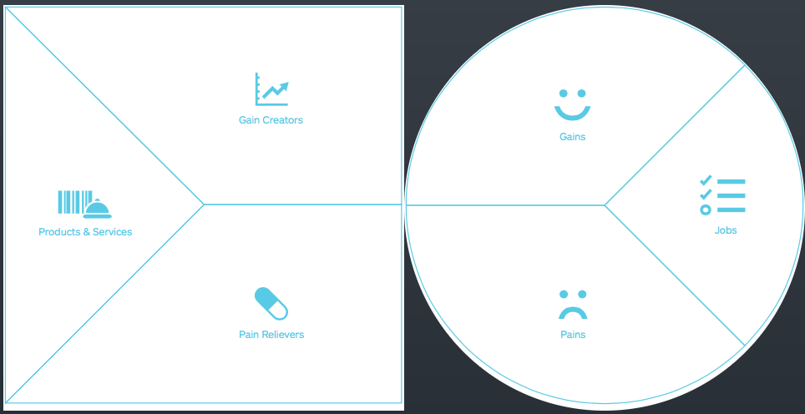

2. SWOT Analysis
• Internal Strength and Weakness of your company
• External Opportunities and Threats for your company. Please indicate what is the probability that certain situation, either positive or negative may occur and indicate what impact this may have on Internal Strength and Weakness of your company

3. Environment Analysis
• List any relevant environment considerations to be aware of when selling your product or service. Ideally you use the business model canvas by Osterwalder which includes PESTEL and Five Forces of Porter therefore analyze according to:
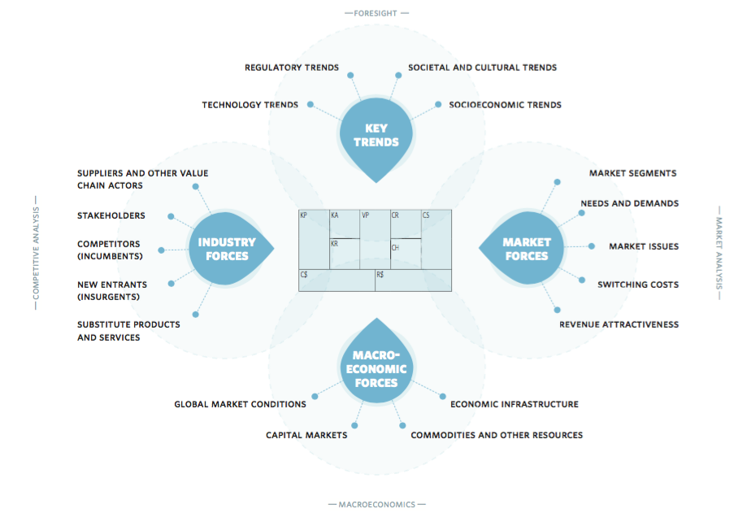
4. Competitive Analysis
• Who are your direct competitors?
• Are there any indirect competitor considerations to be aware of? If someone is not using your product or something similar – what else are they doing?

5. Consumer Analysis
• Demographics and Psychographics
• Geographic Segmentation (if applicable)

Section 2 – Strategic Planning
• Marketing Mix Objectives, Strategies and Tactics (7 Ps)
• Product
• Price
• Place (distribution)
• Promotion (communication)
• Positioning ( in the mind of customers)
• People
• Processes (collaboration across platforms/eco-systems)

Case Study
Coca – Cola’s Many Strategic Pillars

In 2010, Coca-Cola sold 25.5 billion unit cases of drinks across its 500 brands and grew volumes by 5 per cent. Some might say that this performance was exceptional in a recession affected economics climate. Coca-Cola currently sells 1.7 billion drinks every day, but the vision is to double its revenue by 2020, and that represents an annual turnover of £123.4 billion. To do this means growing many of their current brands, which include Coke, Fanta, Sprite, and Powerade, and this entails developing strategies that embrace internal and external environments.
Part of its strategy, according to Coca-Cola chairman and chief executive Muhtar Kent, involves the company avoiding some of the mistakes that it has made in the past. These include nearly going out of business in 1923 when sugar prices skyrocketed and then again when the government rationed sugar in 1940. Other difficulties concerned the launch and sudden retraction of ‘new’ Coke, the Belgium schoolchildren who fell ill after allegedly drinking Coca-Cola employees accused Coca-Cola of racial discrimination. Many of these challenges are regarded by Coca-Cola management as a result of their own arrogance and failure to listen and work with partners as effectively as they should.
Another part of their strategy requires that Coca-Cola develops closer working relationships with its strategic partners, retail customers, and consumers. Such collaboration is necessary so that Coca-Cola earns their trust. Indeed, the current strategy has involved ringing everyone together, including all bottlers and partners, to focus on the brand.

However, Coca-Cola’s strategy is predicated on the knowledge that there are six particular events in the world that have the potential to reshape the industry fundamentally, changed that dwarf the events in the 2000-10. The company recognized that the pace of global socio-economic change would impact heavily on the business and that Coca-Cola needed to start operating differently if it was to thrive. These six global trends have acted as a basis around which the Coca-Cola vision has been developed.
- A growing middle class it is estimated that there will be between 800 million and a billion people entering the middle classes between 2010 and 2020. This is regarded as the greatest economic shift in history. Over 60 per cent of this new wealth will come from emerging nations.
- Mass urbanization Many populations are moving from rural to urban environments. For the next several years, an urban population the size of New York will be created every 90 – 100 days.
- Economic rebalancing Rather than two economic superpowers, there will be a massive rebalancing of economic might, partly a result of the growing middle classes. This includes the ‘BRIC’ countries (Brazil, Russia, India and China), but Indonesia, Turkey, Morocco, Vietnam, Chile, and Mexico are also likely to grow disproportionately.
- The new generation A sophisticated, engaged and well-communicated youth generation is on the rise
- Rising prices There is an increasing scarcity of resources, which leads to volatility in energy prices,
- New consumers have revised their priorities, their values, and their expectations, leading to a new focus on the meaning of the word ‘value’.
1. How might the mistakes made in the past inform marketing strategy for the next ten years?
2. Why do you think Coca-Cola makes no mention of competitors as a platform around which to build its own strategy?
3. How might the six pillars shape Coca-Cola’s future marketing strategy?

