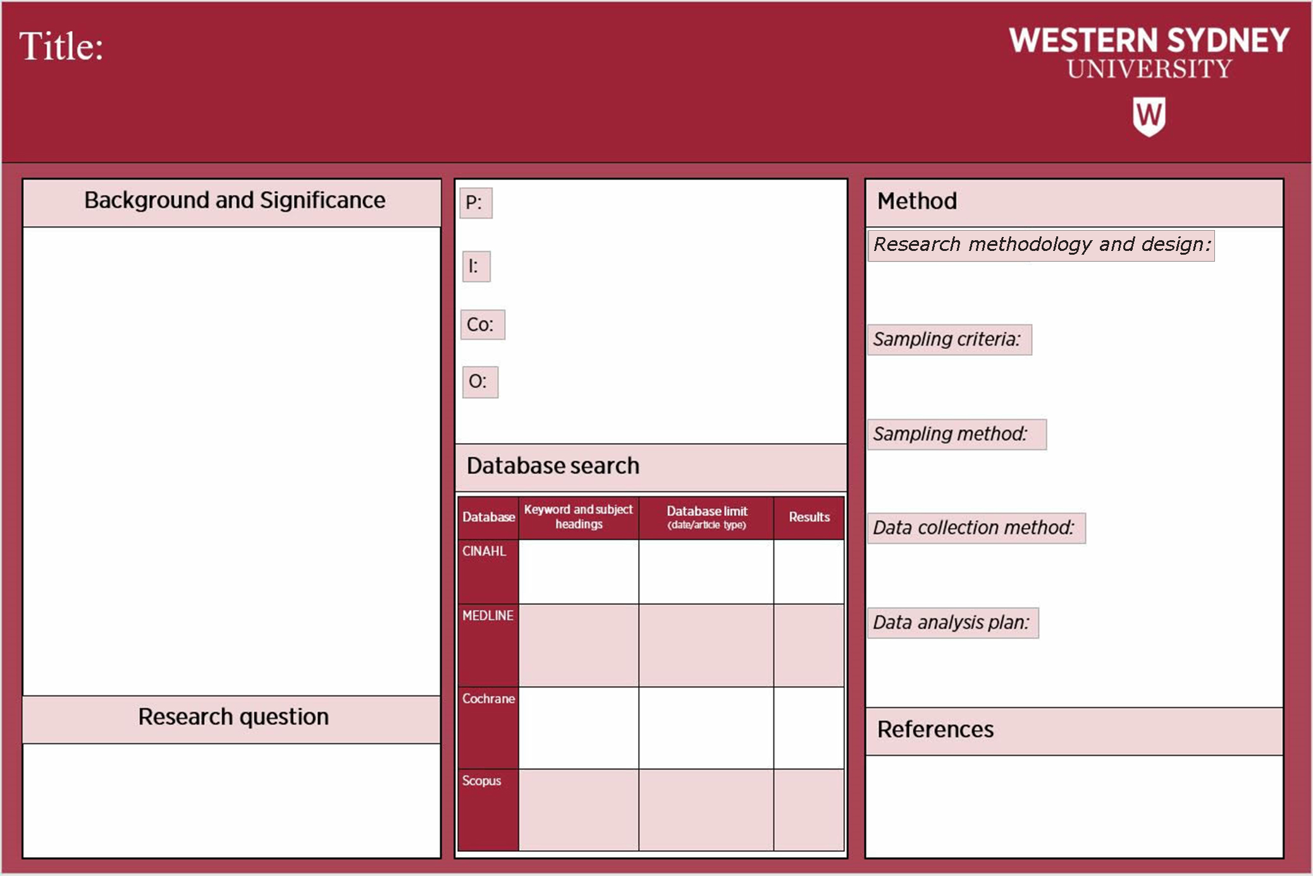
Add Name & Student number here
Add text here
Add text here
Add text here
Add text here
Add text here
Add text here
Add text here
Add title here
Add text here
Add text here
Add text here
Add text here
Add text here
Add text here
Add text here
Add text here
Add text here
Add text here
Add text here
Add text here
Add text here
Add text here
Add text here
Add text here
Add text here

- Provide the rationale for the choice of the research methodology and research design for the research project (300 words)

Add Text here

- Identify and justify the inclusion and exclusion criteria (sampling criteria) and provide rational on its significance for the purpose of the proposed research project and describe how the data will be collected and its appropriateness for the proposed research project (400 words)
Add Text here

3. Provide the rationale for the selection of the data analysis method and why is it appropriate for the proposed research project? (300 words
Add text here

References
Add text here

Add text here

